OC T OBER 11, 2019

LIVE2LEAD is a leader development experience designed to equip attendees with new perspectives, practical tools and key takeaways. You will learn from world-class leadership experts, be prepared to implement a new action plan, and start leading when you get back to the workplace with renewed passion and commitment.

WHO YOU’LL HEAR FROM

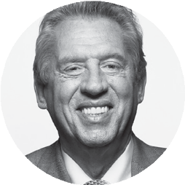
JOHN C. MAXWELL, the #1 New York Times bestselling author, coach, and speaker who has sold more than 30 million books, has been identified as the #1 leader in business by the American Management Association® and the world’s most influential leadership expert by Business Insider and Inc. magazine. Dr. Maxwell has also received the Horatio Alger Award, as well as the Mother Teresa Prize for Global Peace and Leadership from the Luminary Leadership Network. His organizations—The John Maxwell Company, The John Maxwell Team, EQUIP, and the John Maxwell Leadership Foundation—have trained millions of leaders from every nation in the world.

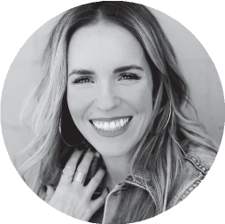
RACHEL HOLLIS is a #1 New York Times & #1 USA Today Bestselling Author, a top business podcaster and one of the most sought-after motivational speakers in the world. As a bestselling author and wildly successful lifestyle influencer she has built a global social media fan base in the millions. She is known as “the Tony Robbins for women” because of her motivational, high energy style and her unique ability to empower and embolden a female audience. She’s a proud working mama of four and a big fan of the small town in Texas hill country that the Hollis family calls home.

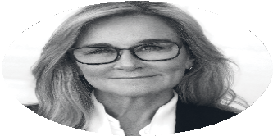
ANGELA AHRENDTS was most recently Senior Vice President of Apple Retail based in Cupertino, CA. During her five years she integrated Apple’s physical and digital businesses to create a seamless customer journey for over a billion visitors a year. Before her transition to Apple, Angela served at Burberry as Chief Executive Officer for nearly nine years where her leadership focus on culture, values and positive energy resulted in tripling the business and quadrupling the share price. Angela has consistently been recognized by Forbes, Fortune and the BBC as a Top 100 Global Executive and is currently a member of the Board of Directors of Ralph Lauren Corp. and Airbnb, and a Well Member with Charity: Water.

MARCUS BUCKINGHAM is a global researcher and thought leader focused on unlocking strengths, increasing performance and pioneering the future of how people work. Building on nearly two decades of experience as a Senior Researcher at Gallup Organization, he currently guides the vision of ADP Research Institute as Head of People + Performance research. He founded The Marcus Buckingham Company in 2006 with a clear mission: to instigate a “strengths revolution.” It started, as all revolutions do, with the simplest of ideas: that when people spend the majority of each day on the job using their greatest talents and engaged in their favorite tasks, basically doing exactly what they want to do, both they and their organizations will win.

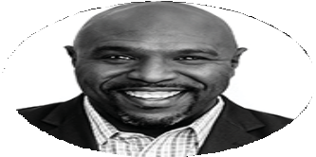
CHRIS HOGAN is the #1 national best-selling author of Everyday Millionaire and Retire Inspired: It’s Not an Age. It’s a Financial Number. For over a decade, Hogan has served at Ramsey Solutions, spreading a message of hope and financial peace across the country as a financial coach and Ramsey Personality. Hogan helps people plan for their future and reach their retirement goals through his Retire Inspired Podcast and live speaking events.

Proceeds benefit local causes. Your facilitator is Marianne T. Bartley, ED.D., Founder, Time to Think, LLC.

Marianne T. Bartley, Ed.D. Founder, Time to Think, LLC. After completing a thirty-four year career as a key educator in both the private and public sectors, Marianne Bartley, of Lebanon, PA, has established a business called Time To Think, LLC. What makes her tick? Personal and professional growth --- leading to transformation of individuals, organizations, and communities.

Marianne provides speaking, coaching, training and leadership development services to corporations, community groups, schools, and individuals. To sum it up, Marianne works with clients to raise the bar on team building, professionalism, health and wellness, and leadership development!

Background: In addition to having extensive leadership experience and a Doctoral Degree in Educational Leadership from Lehigh University, Marianne is an Independent Executive Director of The John Maxwell Team, offering world class expertise to her clients. In addition, she provides corporate and community wellness programs as a certified Health and Wellness Coach with the Dr. Sears Wellness Institute.

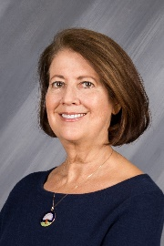

www.timetothink.solutions www.johncmaxwellgroup.com/mariannebartley (717) 821-7212

timetothinkllc@comcast.net

